# **Supply chain analytics use cases:**

Below are some supply chain domains where we can leverage Machine learning to optimize.

**1. Demand Planning**: This supply chain management technique helps businesses forecast future needs for their goods or services and adjust the supply chain appropriately. Demand planning's goal is to precisely forecast demand such that no excess inventory is kept on hand and that no transaction is lost because of a shortage of inventory.

**Procurement:** The financial success of a business is largely dependent on procurement. A company's financial performance and ability to compete in the market depend heavily on a robust and effective procurement procedure. When procurement is operating well, the company may maximise the use of its current resources in addition to producing income.

**Demand forecasting, Analysis of the effect of price and promotion on sales, Anomaly Detection in sales,Forecast Accuracy Analysis, Vendor Ranking and segmentation,Supplier Risk Prediction,Spend Analysis, Transportation/Logistics are the key areas where we can leverage Machine learning to optimize the process.**

**2. Inventory Management:** One of the most important aspects of supply chain management is inventory management. Overstocking and understocking of inventories cause problems for businesses. Low prediction accuracy, supply and demand uncertainty, the bullwhip effect, and logistical problems are the main causes of overstocking. Overstocking frequently results in damaged items and increased inventory holding expenses. Conversely, understocking results in wasted chances and revenue. By forecasting supplier risk, backorders, service level computation, and inventory reorder points that optimize profit, machine learning algorithms assist to reduce this uncertainty.

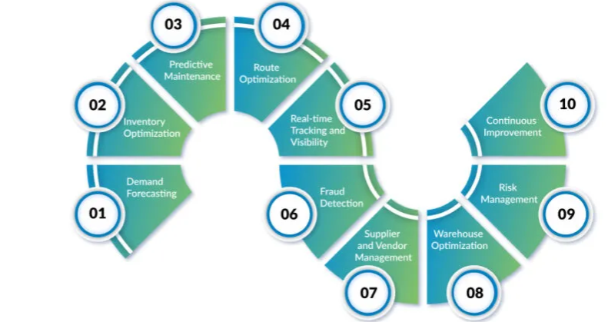

**3. Dynamic Pricing:** The practice of setting product prices depending on demand, market conditions, and customer portfolio is known as dynamic pricing. These days, massive data and increased processing power enable complex dynamic algorithms. Seasonality, market dynamics, competitor pricings, customer segment, purchasing power, and other aspects are all taken into account by the dynamic pricing algorithm, which is now reliable and scalable.

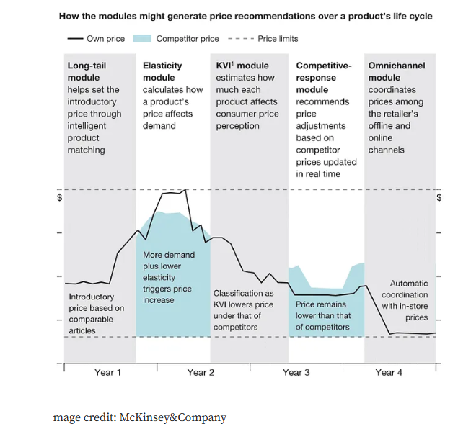

**4. Consumer Behaviour and Purchase Patterns** — Retailers may stream their supply chain by using consumer insights such as buying patterns, customer segments, and customer perceptions of the product to choose which goods to stock, order products seasonally, reduce surplus inventory, enhance service quality, and more. We can create an advanced algorithm using machine learning to extract useful information from consumer behaviour and customer base. Additional information, such as holidays, inflation, and client demographics, aids in the development of more potent machine learning models.